**Name: Sujal Khunt**

**Enrollment NO: 24FOTCA13902**

**1.NETWORK DEVICES:**

**A. ROUTER:**

A router is a device that provides Wi-Fi and is typically connected to a modem. It sends information from the internet to personal devices like computers, phones, and tablets. These internetconnected devices in your home make up your Local Area Network (LAN).

1. **) ISR4331:**



Cisco 4331 Integrated Services Router delivers 100 Mbps to 300 Mbps aggregate throughput and. offers one Enhanced service-module (SM-X) slot, which supports for both single- and double-wide. service modules provides flexibility in deployment options.

1. **) ISR4321:**

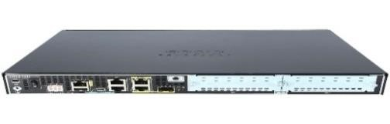

Cisco ISR 4321 features modular network interfaces with diverse connection options for load-balancing and network resiliency and modular interfaces with online removal and insertion (OIR) for module upgrades without network disruption.

1. **) 1941:**

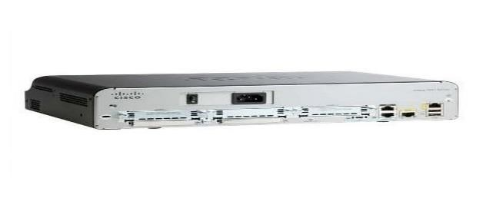

The Cisco 1941 Integrated Services Router (ISR) delivers highly secure data, mobility, and application services. Key features include: 2 integrated 10/100/1000 Ethernet ports. 2 enhanced High-Speed WAN Interface Card slots that can host 2

single wide or 1 double wide and 1 single wide (e)HWIC.

1. **) 2901:**

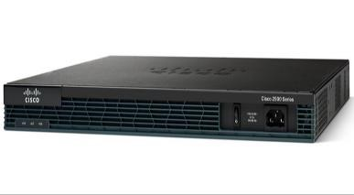

The Cisco 2901 Integrated Services Router (ISR) delivers highly secure data, voice, video, and application services for small offices. Key features include: 2 integrated 10/100/1000 Ethernet ports. 4 enhanced high-speed WAN interface card slots. 2 onboard digital signal processor (DSP) slots.

1. **) 2911:**

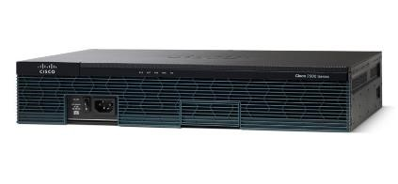

The Cisco 2911 Integrated Services Router (ISR) delivers highly secure data, voice, video, and application service. Key features include: 3 integrated 10/100/1000 Ethernet ports (RJ-45 only) 1 service module slot.

1. **) 829:**

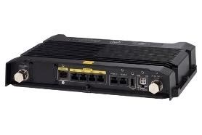

829 Industrial Integrated Services Routers are compact, ruggedized, Cisco IOS Software routers with support for integrated 4G LTE wireless WAN and wireless LAN capabilities. They are: Easily and rapidly deployable. Highly available, highly secure, and reliable.

1. **) 1841:**

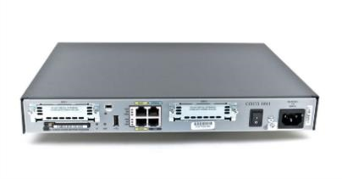

The Cisco 1841 router offers embedded hardware-based encryption enabled by an optional Cisco IOS Software security image; further enhancement of VPN performance with an optional VPN acceleration module; an intrusion prevention system (IPS) and firewall functions; interfaces for a wide range of connectivity requirements ...

1. **) 2811:**

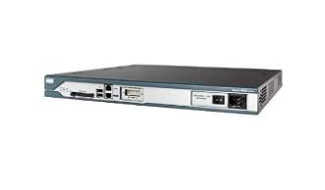

The Cisco 2811 is an integrated services router designed by Cisco to support multiple WAN interfaces. The Cisco 2811 supports multiple T1 / E1 / xDSL connections and has built in support for over 90 Cisco modules. Four high speed WAN slots are available in addition to an enhanced network module slot.

1. **) 819HG-4G-IOX:**

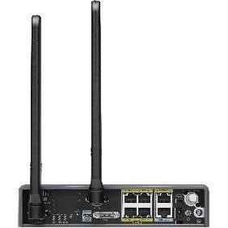

The Cisco 819 Integrated Services Router Family, designed in compact hardened and non-hardened form factors, is the smallest Cisco IOS Software router with support for integrated fourth-generation (4G LTE) wireless WAN (mobile broadband backhaul) and WLAN capabilities.

1. **) 819HGW:**

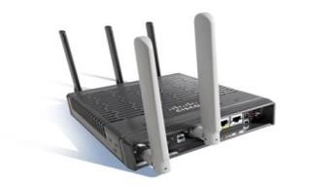

the smallest Cisco IOS® Software router with support for integrated third-generation (3G) wireless WAN (mobile broadband backhaul) and WLAN capabilities.

1. **) ROUTER-PT:**

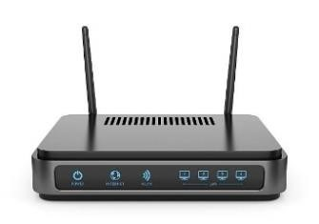

The matrix based PT (Public Transport) router reads a list of PT stops, and constructs “tele- ported” PT routes using the stops nearest to origin and destination.

1. **) ROUTER-PT-EMPTY:**

Router-PT-Empty is a device in Cisco Packet Tracer that allows users to create additional Layer 3 interfaces beyond those available on standard routers. It is particularly useful for networking simulations and educational purposes, enabling flexible configurations for various routing scenarios. However, it operates on a limited version of IOS (12.x), which may not support all advanced features found in real Cisco routers

1. **) CGR1240:**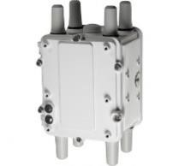

These routers allow utilities to integrate multiple applications, such as advanced metering infrastructure (AMI), distribution automation (DA), integration of distributed energy resources (DER), and remote workforce automation onto a single platform.

1. **) 2620XM:**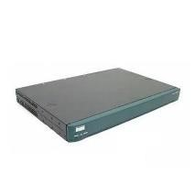

The 2620XM offers flexibility for LAN and WAN configurations, voice and data solutions, and much more. This Cisco fast Ethernet router features a single network module slot, AIMs slot, two WICs slots, and dual Ethernet ports.

1. **) 2621XM:**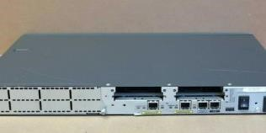

The Cisco 2621XM is a modular enterprise router deisgned by Cisco for deployments that require different WAN connections. The Cisco 2621XM provides flexible LAN ports as well with 2 flexible fast Ethernet ports. The Cisco 2721XM can support a network module and up to two WICs.

**B. SWITCHES:**

1. **) 2950-24:**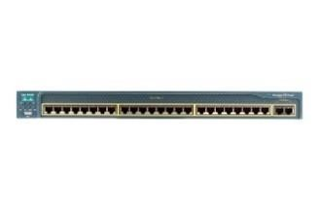

The Cisco Catalyst 2950-24 is a member of the Cisco Catalyst 2950 Series switches, and is a standalone, fixedconfiguration, managed 10/100 switch providing user connectivity for small to mid-sized networks.

1. **) 2960-24TT:**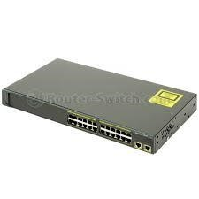

WS- C2960-24TT is one of the Cisco Catalyst 2960 Series switches. Cisco Catalyst 2960 Series. switches support voice, video, data, and highly secure access. They also deliver scalable. management as your business needs change.

1. **) 2950T-24:**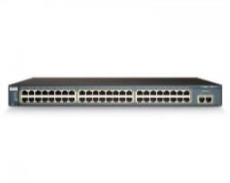

The WS-C2950T-24 Cisco Catalyst is a member of the Catalyst 2950 Series Intelligent Ethernet Switches, and is a fixed-configuration, standalone switch that provides wire-speed Fast Ethernet and Gigabit Ethernet connectivity for midsized networks and the metro access edge.

1. **) IE-2000:**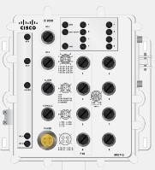

he Cisco ® Industrial Ethernet 2000 (IE 2000) Series is a range of compact, ruggedized access switches that handle security, voice, and video traffic across industrial networks.

1. **) SWITCH-PT:**

It is a fixed-configuration, standalone switch that provides wire-speed Fast Ethernet and Gigabit Ethernet connectivity for mid-sized networks. It does not support add-in modules.

1. **) SWITCH-PT-EMPTY:**

Switch-PT-Empty in Cisco Packet Tracer refers to a type of switch that is completely devoid of any pre-installed modules or interfaces. This allows users to customize the switch by adding various types of modules as needed for their specific network configurations. It serves as a flexible starting point for creating tailored network topologies, enabling users to simulate different networking scenarios effectively

1. **) BRIDGE-PT:**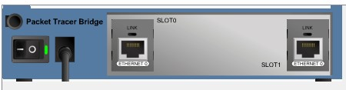

Bridge Physical Therapy provides physical therapy services for most diagnoses seen in an outpatient clinic. We will partner with you and your healthcare team to develop a rehabilitative plan to get you back to your prior level of activities.

1. **) 3650-24PT MULTILAYER:**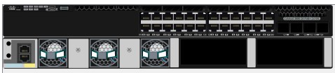

WS-C3650-24PS-S has 24 Gigabit Ethernet POE+ ports with 4 fixed 1G SFP uplink ports and provides fully convergence between wired and wireless capacity on a single platform.

1. **) 3560-24PT MULTILAYER:**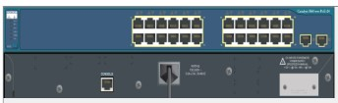

The Cisco Catalyst 3560 24PS Multilayer Switch is a network switch that combines Layer 2 and Layer 3 functionality, making it suitable for both small and medium-sized businesses. It is designed to provide high-performance and reliable connectivity for various network applications.

**C.HUBS:**

1. **) HUB-PT:**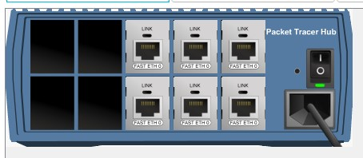

PT Hub is online web mobile app that enables personal trainers,coaches,and gym owner to manage their clients with …….ease.

1. **) REPEATER-PT:**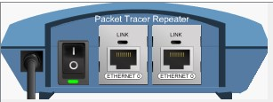

the Repeater PT is a groundbreaking eMTB designed tofulfill all of your powered riding dreams.

1. **) COAXIALSPLITTER-PT:**

As the name implies, a coax signal splitter takes the power on the input port and splits it equally among the output ports.

For example, a 2-way splitter has one input port and two output ports. It sends half the power of the input signal to one of the output ports. The other half is sent to the other output port.

**D. wireless devices:**

1. **) CELL-TOWER:** 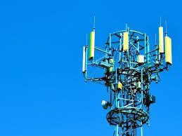

Cell Phone Towers (also called Base Stations), have electronic equipment and antennas that send and receive signals to and from cell phones. Antennas may be attached to free-standing towers or structures or may be mounted on non-tower structures such as building rooftops, billboards or church steeples.

1. **) MERAKI-MX65W:** 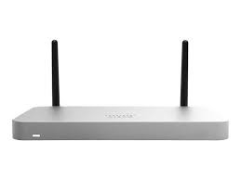

MX65W-HW is a Meraki MX65W Router/Security

Appliance with 802.11ac. Cisco Meraki MX Security & SD-WAN

Appliances are ideal for organizations considering a Unified Threat Management (UTM) solution for distributed sites, campuses or datacenter VPN concentration.

1. **) LAP-PT:**

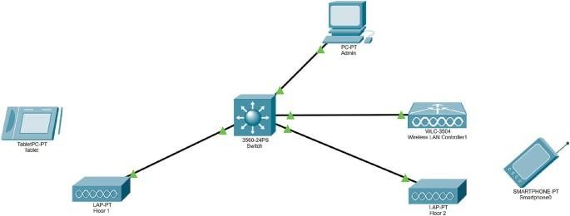

Lightweight Access Points (LAPs) are a type of access point designed to work in conjunction with a Wireless LAN Controller (WLC) within a Cisco Unified Wireless Network architecture. Unlike traditional autonomous access points, LAPs do not operate independently; they rely on the WLC for configuration, management, and firmware updates.

1. **) 3702I:** 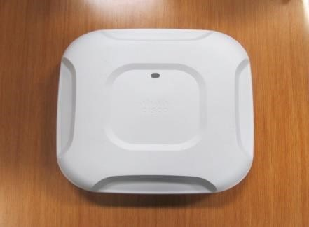

Cisco Aironet 3702i Controller-based - Wireless access point - 802.11ac (draft 5.0) - Wi-Fi - 2.4 GHz, 5 GHz (pack of 10) Manufacturer. Cisco Systems.

1. **) WCL-3504:** 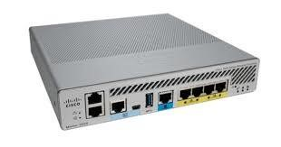

3504 Wireless Controller provides real-time communication between Cisco Aironet Access Points, Cisco Prime Infrastructure, and Cisco Mobility Services Engine. Cisco 3504 Wireless Controller is interoperable with Cisco 5520 and 8540 Wireless Controllers.

1. **) WCL-2504:** 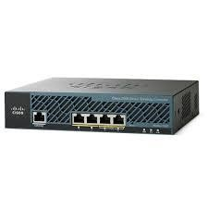

2504 Wireless Controller, is a model within the Cisco 2500 Series designed for managing wireless networks. It supports up to 50 lightweight access points (LAPs) and integrates with Cisco's Unified Wireless Network architecture to provide centralized management of wireless networks.

1. **) HOME-ROUTER-PT-AC:**

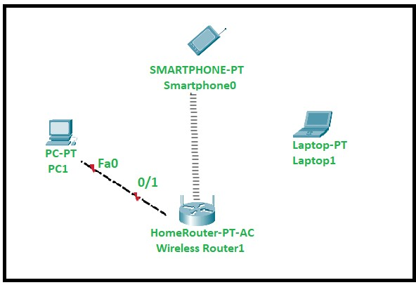

The HomeRouter-PT-AC in Cisco refers to a simulated wireless router used in Cisco Packet Tracer, a network simulation tool. It allows users to design and configure small to medium-sized networks, enabling the practice of networking concepts such as DHCP, IP addressing, and wireless connectivity.

**VIII ) ACCESSPOINT**

**-**

**PT:**

v

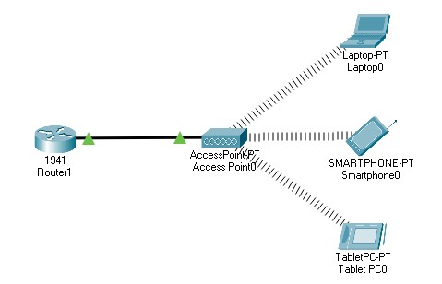

The Access Point-PT in Cisco refers to a simulated wireless access point available in Cisco Packet Tracer, a network simulation tool. It allows users to configure and practice setting up wireless networks, enabling devices like laptops and smartphones to connect wirelessly. Users can easily set parameters such as SSID, security settings, and DHCP configurations to manage wireless connectivity within a simulated environment, making it a valuable educational resource for learning networking concepts.

* + 1. **) ACCESSPOINT-PT-A:**



The Access Point-PT-A in Cisco refers to a simulated wireless access point used in Cisco Packet Tracer, a network simulation tool. It allows users to design and configure wireless networks within the simulation environment, enabling practice with settings like SSID, security protocols, and DHCP configurations. This tool is particularly useful for learning and teaching networking concepts without the need for physical hardware.

* + 1. **) ACCESSPOINT-PT-N:**

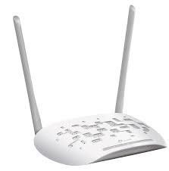

The Access Point-PT-N in Cisco refers to a simulated wireless access point available in Cisco Packet Tracer, a network simulation tool. It allows users to create and configure wireless networks, enabling connectivity for devices like laptops and smartphones within the simulation environment. Users can set parameters such as SSID, security settings, and DHCP configurations, making it a practical resource for learning networking concepts without needing physical hardware.

* + 1. **) ACCESSPOINT-PT-AC:**

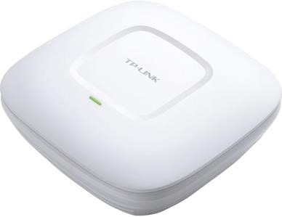

The Access Point-PT-AC in Cisco refers to a simulated wireless access point available in Cisco Packet Tracer, designed for educational purposes. It allows users to create and configure wireless networks within the simulation environment, enabling practice with settings such as SSID, security protocols, and DHCP configurations. This tool is particularly useful for learning networking concepts and troubleshooting without the need for physical hardware, making it an effective resource for students and professionals alike.

* + 1. **) WRT300N:** 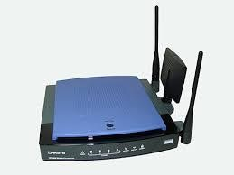

The Cisco-Linksys WRT300N is a Wireless-N broadband router that supports the 802.11n standard, allowing for wireless connectivity at speeds up to 130 Mbps on the 2.4 GHz band. It features a built-in 4-port Ethernet switch for wired connections and offers functionalities like DHCP services and wireless access point capabilities. Designed for home use, the WRT300N provides a reliable solution for connecting multiple devices to the internet wirelessly while maintaining good signal coverage.

* + 1. **) CENTERL-OFFICE-SERVER:**

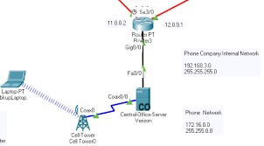

The Central Office Server in Cisco refers to a simulated server used in Packet Tracer, a network simulation tool, to represent the central office equipment found in telecommunications networks. It is typically configured with DHCP services to assign IP addresses to connected devices like smartphones and PCs.

* + 1. **) DLC100 HOME GATEWAY:**

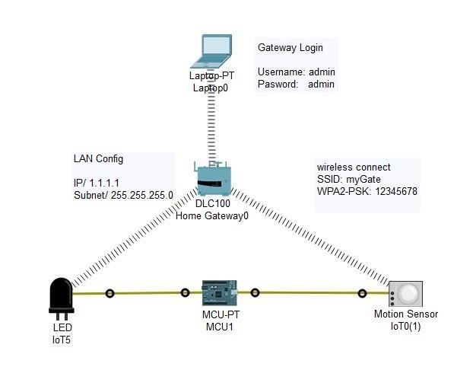

The DLC100 Home Gateway in Cisco is a device used to connect and manage smart home devices within a network. It acts as a central hub, allowing users to register and control various smart appliances, such as cameras, motion detectors, and smart lights, by assigning IP addresses to each device. This gateway facilitates remote access through smartphones or applications, enabling users to monitor and manage their smart home environment effectively.

**E. SECURITY:**

* + - 1. **) 5505 ASA1:**

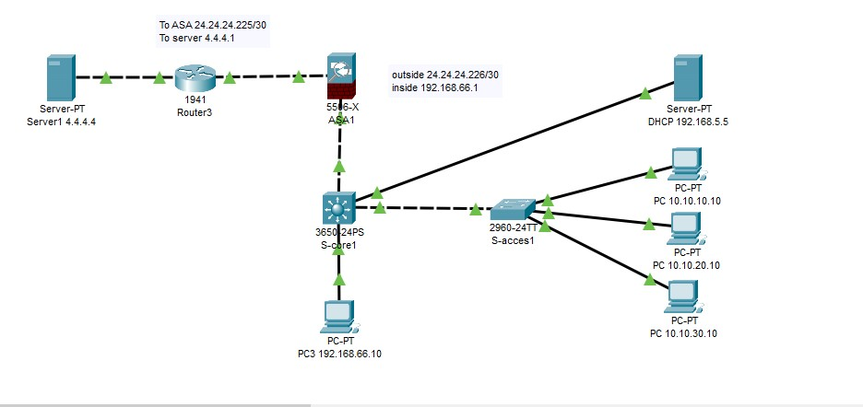

The Cisco ASA1 5505, often referred to as "5505 ASA1," is a compact adaptive security appliance designed for small businesses, branch offices, and teleworkers. It provides highperformance firewall capabilities, SSL and IPsec VPN support, and rich networking services in a modular, plug-and-play format. The ASA 5505 features an 8-port Fast Ethernet switch, supports up to 50 users, and offers advanced security features like intrusion prevention and the ability to create multiple VLANs for improved network segmentation.

* + - 1. **) 5506-X ASA0:**

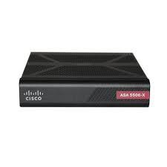

The Cisco ASA0 5506-X is a next-generation firewall that provides advanced security features for small to medium-sized businesses. It offers a range of security services to protect networks from cyber threats, including firewall, intrusion prevention, VPN, and advanced malware protection.

**F. WAN EMULATION I ) CLOUD-PT:**

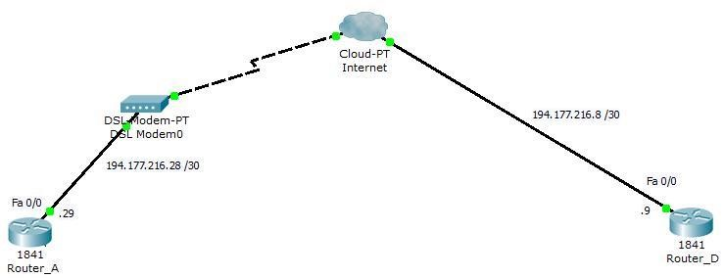

This device looks like a cloud in the toolbar, but under the configuration window it looks more like a router with several slots. The following modules are available for the cloud device: NM-1AM: This module provides an RJ11 connector for connecting modems using telephone cables.

**) CLOUD-PT-EMPTY:**

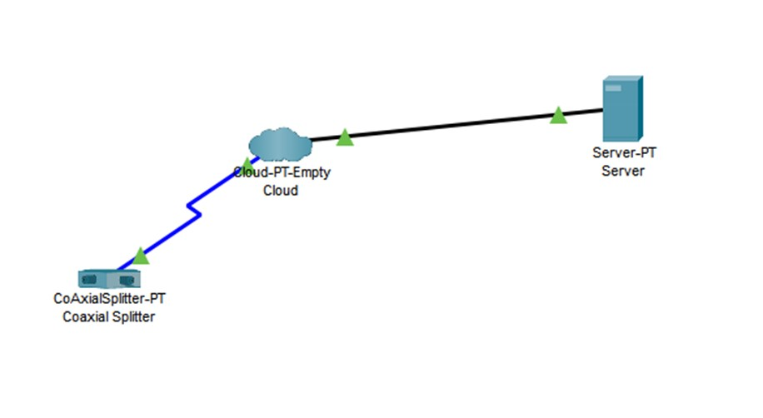

Cisco Packet Tracer, PT-Cloud and PT-Empty serve different purposes. PT-Cloud is a simulated cloud environment that includes pre-installed modules for connecting various devices, allowing users to emulate internet connectivity and network configurations. In contrast, PT-Empty is a blank canvas without any pre-installed modules, providing users the flexibility to create their own configurations from scratch

**) DSL-MODEM-PT:**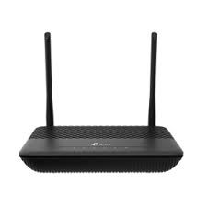

Cisco Packet Tracer, the DSL-MODEM-PT is a simulated Digital Subscriber Line (DSL) modem used to emulate DSL connectivity for network simulations. It allows users to connect a router to a simulated internet environment, enabling the testing of various configurations and network setups. The DSL modem can be configured to simulate real-world scenarios, such as connecting to an Internet Service Provider (ISP) and managing data transmission over existing telephone lines. This device is essential for practicing network configurations involving DSL technology in a controlled environment.

**) CABLE-MODEM-PT:**

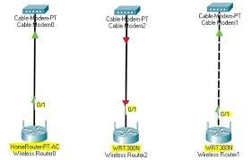Packet Tracer,

the CABLE-MODEM-PT is a simulated cable modem that enables users to emulate a cable internet connection. It allows for the connection of routers to a simulated internet environment, facilitating the testing of various network configurations. Users can configure the modem to mimic real-world settings provided by cable ISPs, such as DHCP, to establish connectivity for network simulations. This device is essential for practicing and understanding cable networking in a controlled environment.

**2.END DEVICES:**

**A. END DEVICES:**

* + 1. **) PC-PT:**

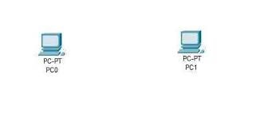

The location of the curve's start point is defined as the Point of Curve (PC) while the location of the curve's end point is defined as the Point of Tangent (PT). Both the PC and PT are a distance T from the PI, where T is defined as Tangent Length.

* + 1. **) TV-PT:**

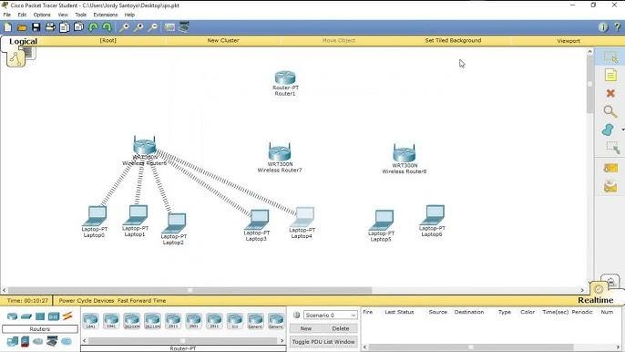

TV-PT (Terrestrial Video-Powered Transmission) is a digital communication technology used for transmitting video signals over terrestrial networks. It is a variant of the DVB-T (Digital Video Broadcasting - Terrestrial) standard, which is widely used for digital terrestrial television broadcasting. TV-PT allows for the transmission of high-quality video content, such as HD and 4K, over existing terrestrial infrastructure, making it a cost-effective solution for video distribution in areas where cable or satellite networks are not readily available

* + 1. **) TABLETPC-PT:**

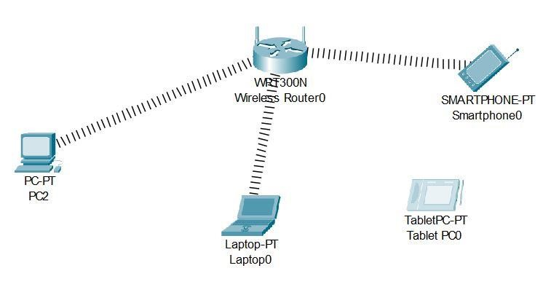

TABLETPC-PT refers to a Tablet Personal Computer with enhanced capabilities for digital communication. It combines the functionalities of a traditional computer with a touchscreen interface, enabling users to interact using a stylus or their fingers. This device supports various operating systems and is designed for portability, allowing for efficient communication and productivity in various environments.

* + 1. **) LAPTOP-**



LAPTOP-PT refers to a Laptop Personal Computer designed for digital communication purposes. These devices are portable computers equipped with advanced connectivity options, such as Wi-Fi and Bluetooth, enabling users to engage in various forms of digital communication, including video conferencing, email, and social networking. Laptops typically feature a built-in keyboard and trackpad, making them versatile tools for both personal and professional use in digital communication environments.

* + 1. **) SMARTPHONE-PT:**



SMARTPHONE-PT refers to a Smartphone Personal Technology designed for digital communication. These devices integrate advanced features such as internet connectivity, multimedia capabilities, and various applications that facilitate instant messaging, video calls, and social networking. Smartphones have become essential tools for personal and professional communication, enabling users to connect seamlessly across different platforms and locations.

* + 1. **) PRINTER-PT:**

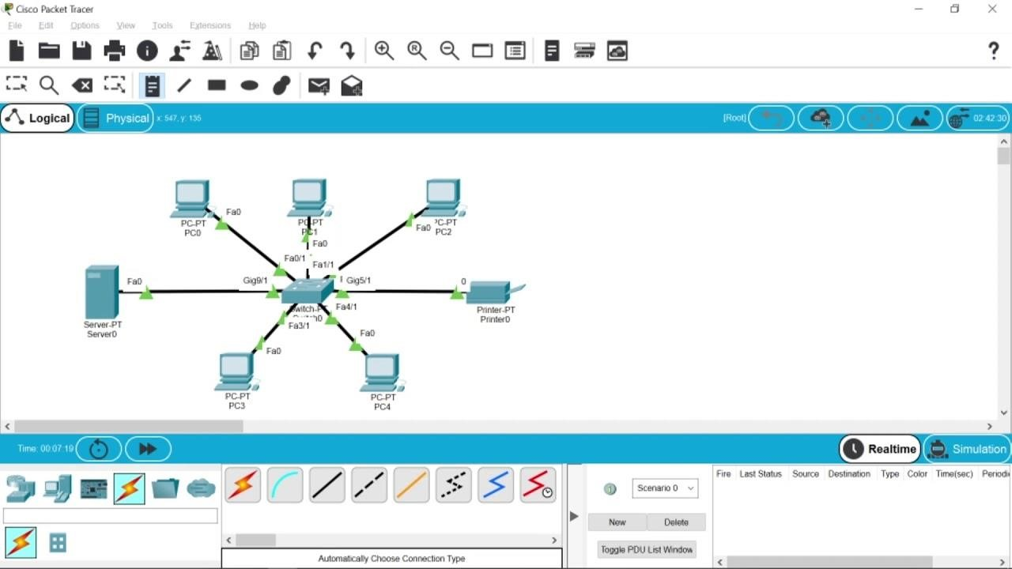

PRINTER-PT refers to a Printer Personal Technology used in digital communication for producing hard copies of digital documents and images. These printers can connect wirelessly or via USB to computers and mobile devices, allowing for the seamless transfer of digital content for printing. They play a crucial role in various settings, including offices and homes, by enabling the physical distribution of information generated through digital communication channels.

* + 1. **) SERVER-PT:**



SERVER-PT refers to a Server Personal Technology used in digital communication, which provides resources, data, and services to other computers, known as clients, over a network. Servers are essential for hosting websites, managing email, and facilitating file sharing, enabling efficient communication and collaboration among users. They can be dedicated hardware or virtualized environments, and they play a crucial role in ensuring reliable and scalable digital communication systems.

* + 1. **) MERAKI-SERVER:**

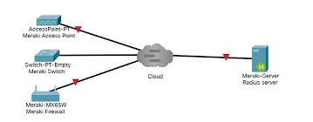

MERAKI-SERVER refers to the cloud-based server infrastructure used by Cisco Meraki for managing network devices and services. It facilitates communication between Meraki hardware and the Meraki dashboard, allowing for configuration management, data collection, and analytics. This architecture ensures high availability and reliability by enabling devices to maintain functionality even during cloud connectivity loss, while securely transmitting data using encrypted connections

* + 1. **) NETWORKCONTROLLER-PT:**

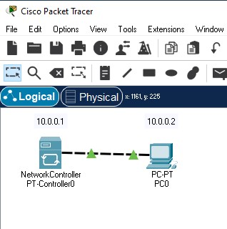

NETWORKCONTROLLER-PT refers to a Network Controller Personal Technology used in digital communication to manage and control network resources and traffic. It facilitates communication between various network devices, ensuring efficient data flow and connectivity. This technology is crucial for optimizing network performance, enabling features like load balancing, security management, and real-time monitoring of network activities.

* + 1. **) 7960 IP PHONE:**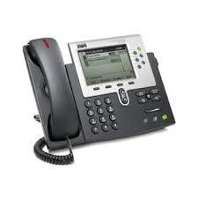

The Cisco 7960 IP Phone is a full-featured VoIP telephone designed for professional use in office environments with high call volumes. It features a large LCD display, 6 programmable line keys, 4 soft keys, built-in speakerphone and headset support, enabling efficient call management and hands-free communication. The Cisco 7960 IP Phone connects directly to an IP network, eliminating the need for traditional PBX systems and allowing for cost-effective VoIP telephony in modern office settings.

* + 1. **) SNIFFER:**

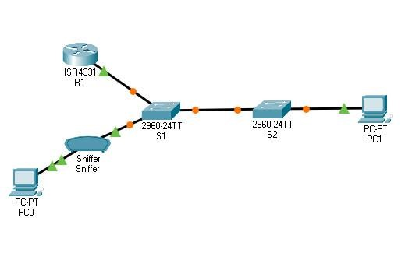

A sniffer, also known as a packet analyzer, is a tool used in digital communication to capture and analyze network traffic. It intercepts data packets transmitted over a network, allowing users to monitor and troubleshoot network performance or security issues. Sniffers can be employed for legitimate purposes, such as network management, but they can also be misused for malicious activities, like intercepting sensitive information.

* + - 1. **) ANALOG-PHONE-PT:**

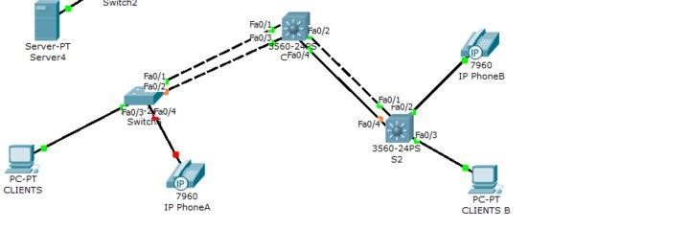

ANALOG-PHONE-PT refers to a type of telephone that operates using analog technology, which converts sound waves into electronic signals. This traditional phone system, often referred to as POTS (Plain Old Telephone Service), transmits voice data through electrical pulses over copper wires. While analog phones are simpler and less expensive, they typically offer fewer features and lower sound quality compared to digital phones, which use binary data transmission for clearer communication.

* + - 1. **) HOME-VOIP-PT:**

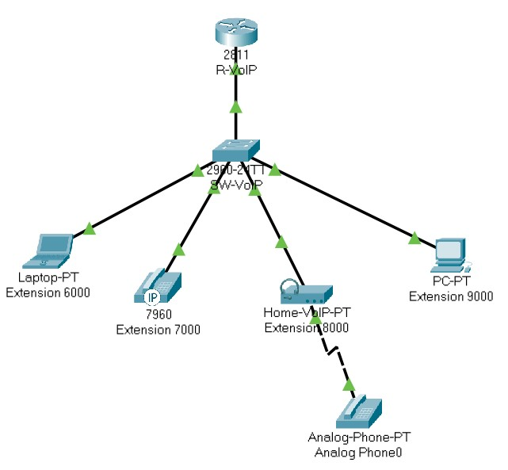

HOME-VOIP-PT refers to a home Voice over Internet Protocol (VoIP) system that allows users to make and receive phone calls using their internet connection instead of traditional telephone lines. This technology enables features such as call forwarding, voicemail, and video calling, often at lower costs compared to conventional phone services. Home VoIP systems typically require a compatible device, such as a VoIP phone or adapter, and can provide enhanced communication options for residential users.

* + - 1. **) WIRELESSENDDEVICE-PT:**

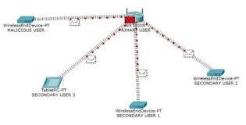

WIRELESSENDDEVICE-PT refers to a type of device in digital communication that connects to a network wirelessly, enabling data transmission without physical cables. These devices can include smartphones, tablets, laptops, and IoT (Internet of Things) gadgets, allowing users to communicate and access information seamlessly over wireless networks. Wireless end devices enhance mobility and flexibility, making them essential for modern digital communication environments.

* + - 1. **) WIREDDENDDEVICE:**

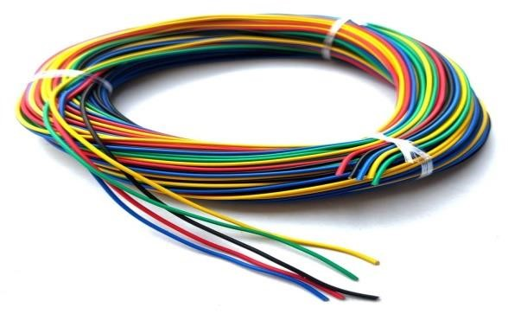

WIREDENDDEVICE-PT refers to a device in digital communication that connects to a network using a physical wired connection, such as Ethernet cables. These devices establish a direct link to the network infrastructure, providing a reliable and secure means of data transmission. Examples of wired end devices include desktop computers, IP phones, and industrial automation equipment, which leverage wired connectivity for consistent performance and reduced interference compared to wireless alternatives.

**B. HOME:**

* + - * 1. **) AIR CONDITIONER:**

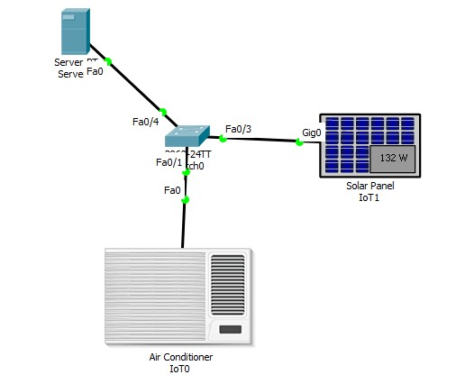

An air conditioner in digital communication refers to a system that utilizes communication modules to manage and control air conditioning units. These modules enable communication between indoor and outdoor units, allowing for efficient operation and monitoring of temperature settings, energy consumption, and system diagnostics. Advanced air conditioning systems may utilize technologies such as power line communication or wireless protocols to facilitate data exchange, enhancing overall system performance and user experience.

* + - * 1. **) APPLIANCE:**

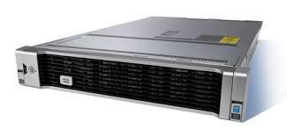

In the context of digital communication, an appliance typically refers to a device that incorporates communication capabilities to enable remote monitoring, control, and integration with other systems. These appliances can include smart home devices like thermostats, security systems, and lighting controls, which can be accessed and managed through digital interfaces and communication protocols. By integrating digital communication features, appliances can provide enhanced functionality, energy efficiency, and convenience for users in residential and commercial settings.

* + - * 1. **) BETTERY:** 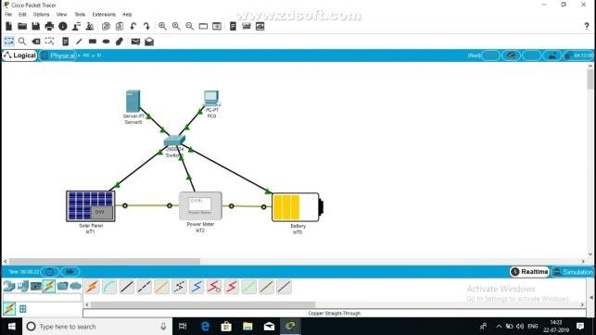

A battery is a device that stores electrical energy and supplies power to electronic devices, enabling their operation in portable and mobile applications. In digital communication, batteries are crucial for powering devices such as smartphones, laptops, and IoT devices, allowing for uninterrupted connectivity and communication without reliance on direct power sources.

**IV: BLUETOOTH SPEAKER:** 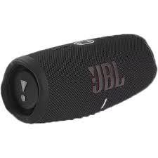

A Bluetooth speaker is a wireless audio device that connects to other Bluetooth-enabled devices, such as smartphones or laptops, to receive and play digital audio signals. Utilizing Bluetooth technology, these speakers allow users to enjoy music and other audio content without the need for physical cables, providing convenience and portability. They typically feature built-in amplifiers and drivers to convert digital signals into sound, making them popular for both personal and outdoor use.

**V ) HOME SPEAKER:**

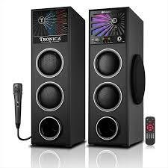

A home speaker in the context of digital communication refers to a wireless audio device designed for use in residential settings. These speakers typically connect to smartphones, tablets, or computers via Bluetooth or Wi-Fi, allowing users to stream music, podcasts, and other audio content from various digital sources. Home speakers often feature built-in voice assistants, enabling handsfree control and integration with smart home devices, further enhancing their functionality in a digital communication environment.

**VI ) SOLAR PENEL:**

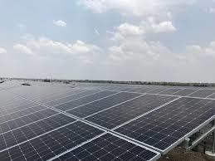

A solar panel in digital communication refers to a device that converts sunlight into electrical energy, which can be used to power communication systems or devices. These panels can also be utilized in innovative applications such as Visible Light Communication (VLC), where they serve as receivers for data transmitted via light. By harnessing solar energy, they provide a sustainable power source for various digital communication technologies, enhancing energy efficiency and reducing reliance on traditional power sources.

**VII ) WEBCAM:**

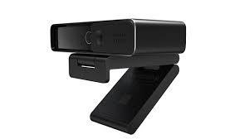

A webcam is a video camera designed to record or stream video to a computer or computer network. It is primarily used for video telephony, live streaming, and security

surveillance. Webcams can be built-in hardware or external devices, typically connected via USB or wireless protocols. They enable realtime visual communication and collaboration in various digital environments, from video conferencing to online education and content creation.

1. **) POWER METER:**

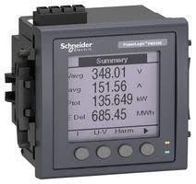

A power meter in digital communication is an advanced device used to measure and analyze electrical power consumption and various electrical parameters in real-time. These meters can connect to communication networks, allowing for remote monitoring and management of energy usage through protocols like Modbus, GPRS, and Wi-Fi. By providing accurate data on energy consumption, power meters facilitate better energy management and efficiency in both residential and industrial applications.

1. **) WINDOW:**

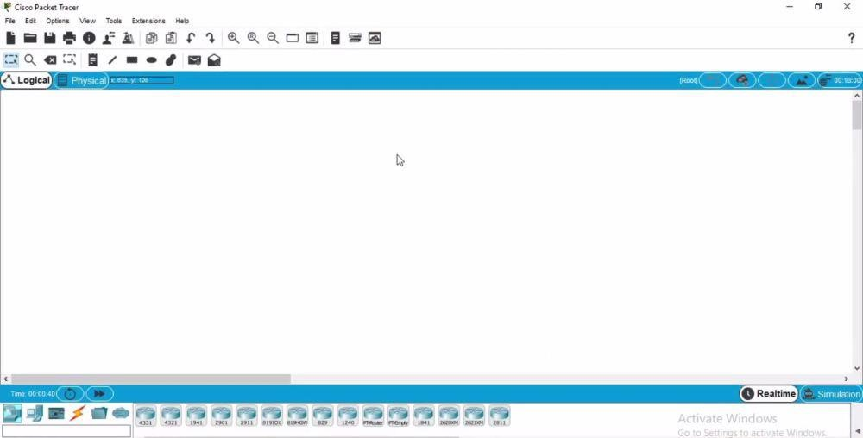

a window often refers to a technique used in data transmission protocols, such as the sliding window protocol. This method allows multiple data frames to be sent before requiring an acknowledgment for the first one, enhancing the efficiency of data flow between devices. By managing the number of frames in transit, the window mechanism helps control data transmission rates, reduce latency, and improve overall communication reliability in network systems.

1. **) WATER DRAIN:**



WATER DRAIN in digital communication refers to a system that utilizes digital technologies to monitor and control the drainage of water. This can involve sensors, controllers, and communication modules to gather data on water levels, flow rates, and drainage patterns, enabling efficient management of water resources. By integrating digital communication capabilities, water drain systems can provide real-time monitoring, remote access, and automated control, optimizing drainage operations and reducing the risk of flooding or water-related issues.

1. **) FAN:**

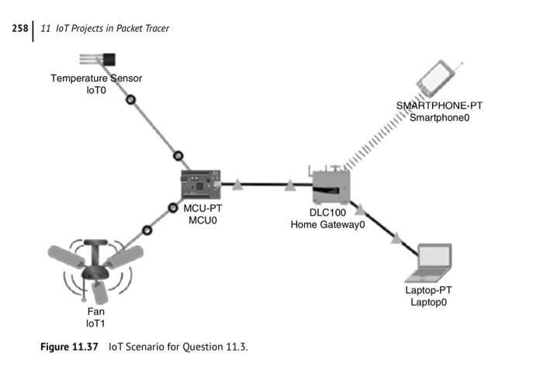

Electric fans have a motor that turns a shaft on which there is an impeller. The turning impeller creates air pressure, causing air flow. If the fan moves air in the same direction as its shaft, it is axial flow.

1. **) PORTABLE MUSIC PLAYER:**

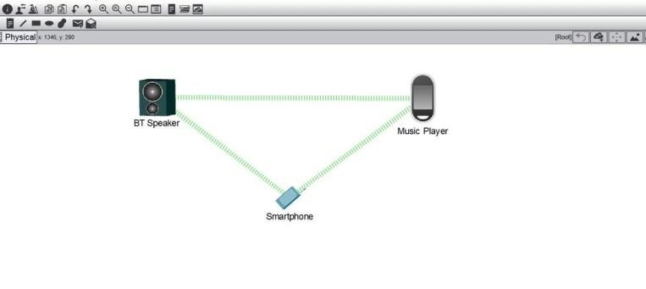

A portable media player (PMP) or digital audio player (DAP) is a portable consumer electronics device capable of storing and playing digital media such as audio

1. **) DOOR:**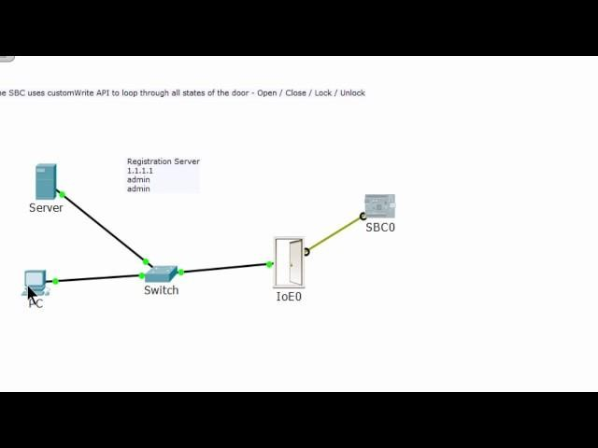

a usually swinging or sliding barrier by which an entry is closed and opened. also : a similar part of a piece of furniture.

1. **) LIGHT:** 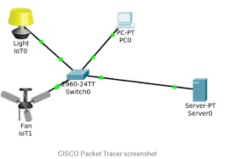

Light is defined as the electromagnetic radiation with wavelengths between 380 and 750 nm which is visible to the human eye.

1. **) WIND DETECTOR:**

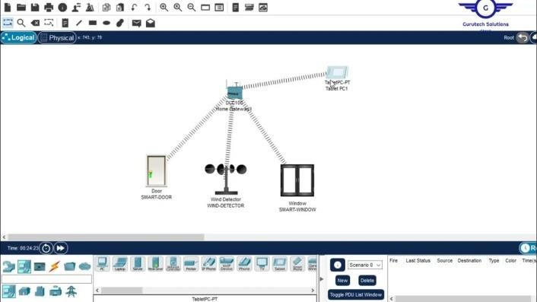

In meteorology, an anemometer is a device that measures wind speed and direction. It is a common instrument used in weather stations.

1. **) FURNACE:**

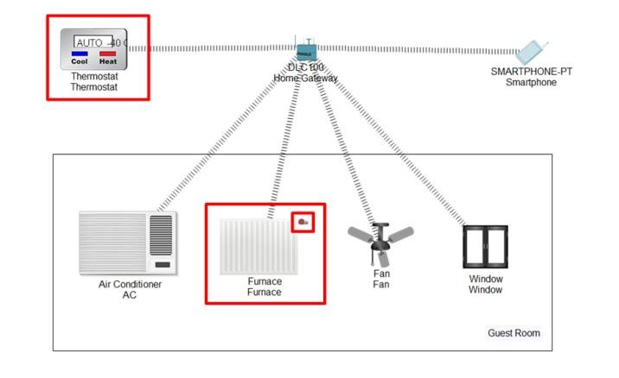

a furnace, or a heater or boiler, used to generate heat for buildings. Boiler, used to heat water; also called a furnace in American English when used for heating and hot water in a building.

1. **) GARAGE DOOR:**

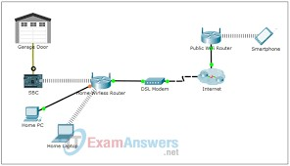

a large door that covers the opening through which a car enters and leaves a garage.

1. **) HUMIDIFIER:**



A humidifier is a device that increases the humidity (moisture content) of the air in a room or building. There are several types of humidifiers used in digital communication

1. **) WATER LEVEL MONITOR:**

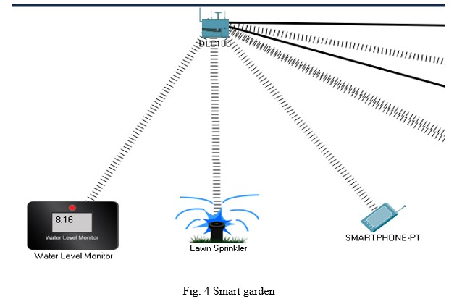

It consists of sensor devices, which automatically detect the level of water inside any tank. The solution provides actionable insights for the managers to make wise & necessary decisions in situations of leakages or overspilling of tanks.

1. **) MOTION DETECTOR:**

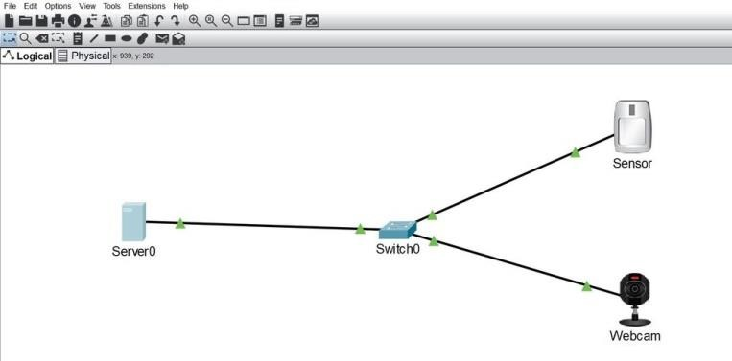

A motion detector is an electronic device designed to detect nearby motion, often used as part of security systems or automated lighting controls. It typically employs various sensors, such as passive infrared (PIR), microwave, or ultrasonic, to sense movement by detecting changes in the environment, like heat or sound waves. When motion is detected, the device can trigger alarms, activate lights, or send alerts to users, enhancing security and energy efficiency in homes and businesses.

1. **) LAWN SPRINKLER:**

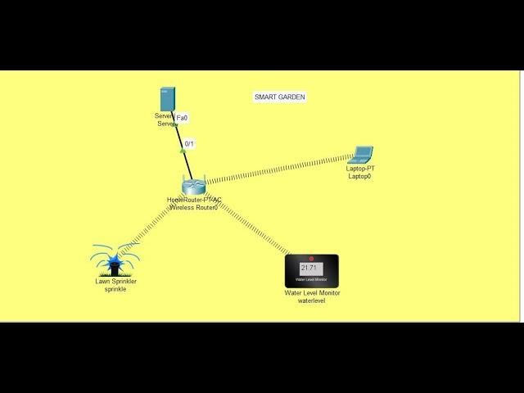

A sprinkler is a garden device that sprays water onto your grass or plants. You can attach a small lawn sprinkler to a hose in your yard when your flowers are looking droopy. Sprinklers are mainly used to irrigate, or provide water, to plants.

1. **) SMOKE DETECTOR:**

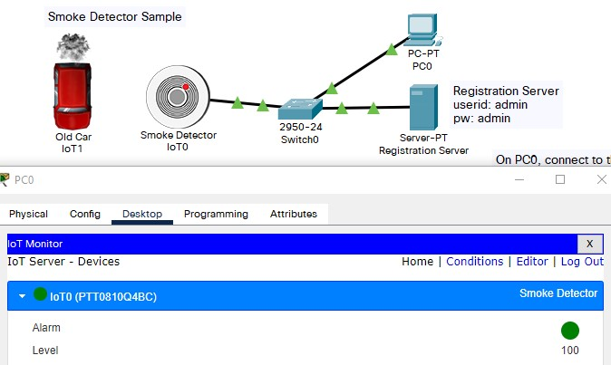

Smoke alarms detect fires by sensing small particles in the air. Once they detect those particles above a certain level, they signal the alarm to sound so that you and your family can get to safety and call 911.

1. **) THERMOSTAT:**

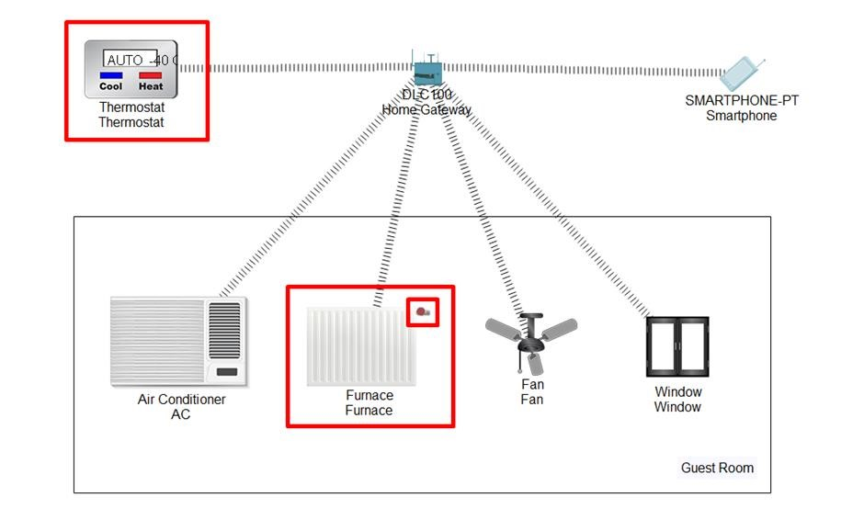

A thermostat is a device that maintains a system at a constant temperature by automatically controlling the heating or cooling system. It consists of a temperature sensor that measures the current temperature and a switch that turns the heating or cooling on or off to keep the temperature at a desired setpoint.

1. **) TEMPERATURE MONITOR:**

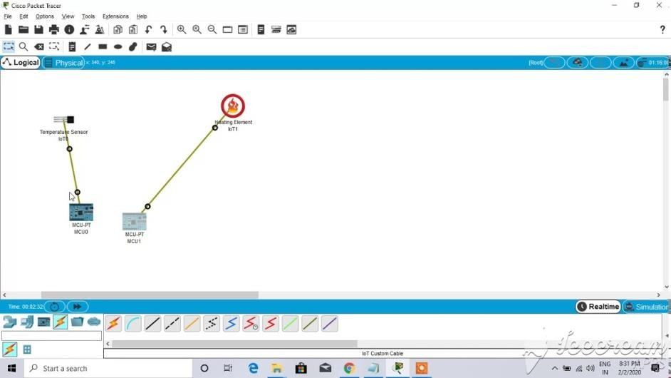

Temperature monitoring is the process of measuring and recording the temperature of a specific environment or process in order to control it.

1. **) SOUND FRQUENCY DETECTOR:**

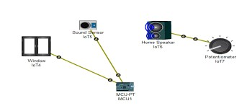

A sound frequency detector is a device or system designed to measure and identify the frequency of sound waves. It typically utilizes a microphone or sound sensor to capture audio signals, which are then processed to determine their frequency characteristics.

1. **) HUMIDITY MONITOR:**

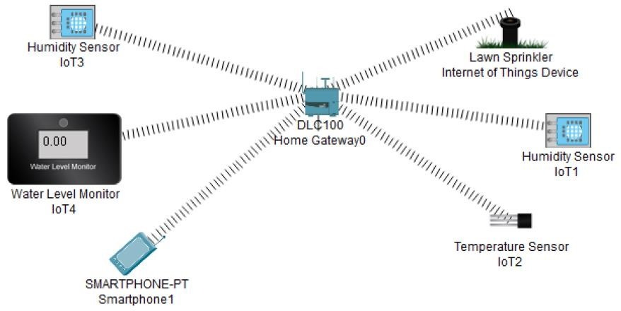

Humidity sensors, also known as hygrometers, are a type of humidity sensor. This equipment is used to determine the actual humidity level in the air at any time or location. These devices are frequently used in conditions where air conditions are severe or where controlling air situations is a must for various reasons.

1. **) HUMITURE MONITOR:**

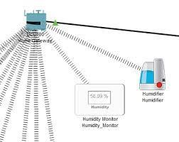

A humiture sensor module to test temperature and humidity, which uses the sensor DHT11. Humidity measurement range: 20 - 90%RH. Temperature measurement range: 0 - 60℃. Output digital signals indicating temperature and humidity.

1. **) CARBON DIOXIDE DETECTOR:**

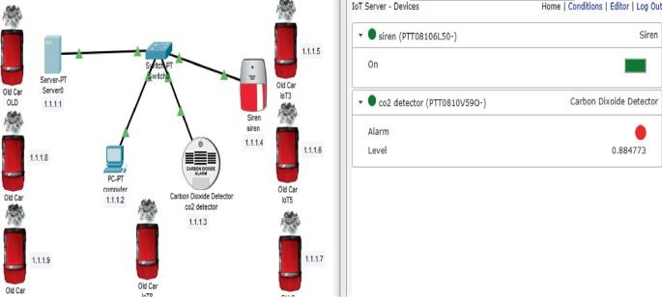

A carbon dioxide (CO2) detector is a device designed to monitor and measure the concentration of carbon dioxide gas in the environment. CO2 is a colorless and odorless gas that is vital for life but can become hazardous at elevated levels, especially indoors.

1. **) CARBON MONOXIDE DETECTOR:**

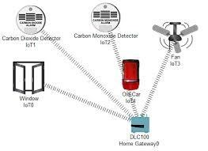

A carbon monoxide detector is a safety device designed to detect the presence of carbon monoxide (CO), a colorless, odorless, and poisonous gas that can be produced by fuel-burning appliances, vehicles, and other combustion processes. These detectors serve as an essential warning system against the dangers of carbon monoxide poisoning, which can occur from faulty appliances or improper ventilation, leading to serious health risks or even death.

1. **) SIREN:**

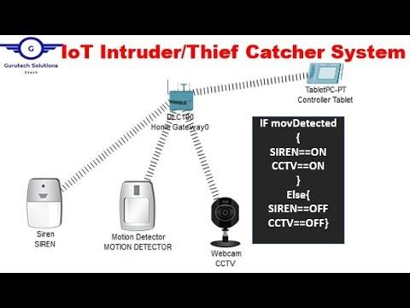

A siren in digital communication refers to a loud noise-making device used primarily for alerting the public to emergencies, such as natural disasters or attacks. These sirens can be mechanical or electronic, with the latter often integrated into broader warning systems that utilize various tones and signals to convey different types of alerts. Electronic sirens may also transmit voice messages, enhancing their effectiveness in emergency situations.

1. **SMART CITY:** 
   1. **) BEACOM:**

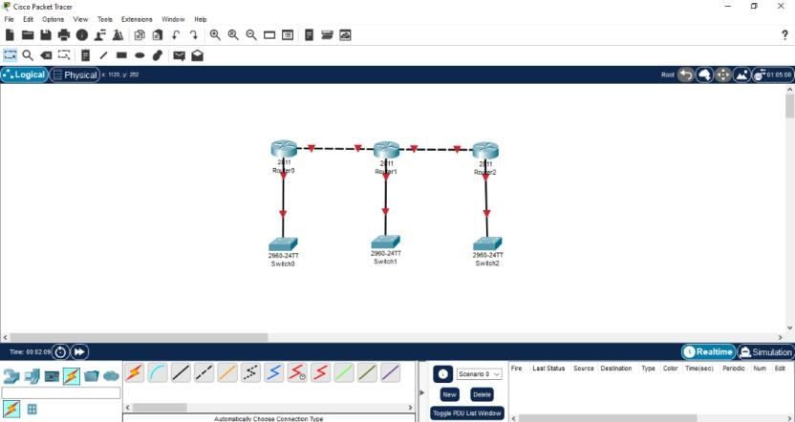

* + 1. beacon refers to a signal or message that is transmitted periodically to announce the presence of a device or network. Specifically, in wireless networks, a beacon frame is a type of management frame used in IEEE 802.11 WLANs, which provides essential information about the network, including its presence and synchronization details for connected devices. These frames help maintain network organization and facilitate communication among devices within the network.

* 1. **) OLD CAR:**

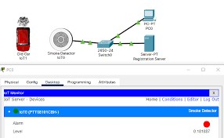

The term "OLLD CAR" does not appear to have a specific definition or commonly recognized meaning in the context of automotive or digital communication. If you meant "old car," it typically refers to vehicles that are considered vintage or classic, often characterized by their age, design, and historical significance. These cars may lack modern technology and digital communication systems found in newer vehicles. If "OLLD CAR" refers to something else, please provide more context for clarification.

* 1. **) SMART LED:**

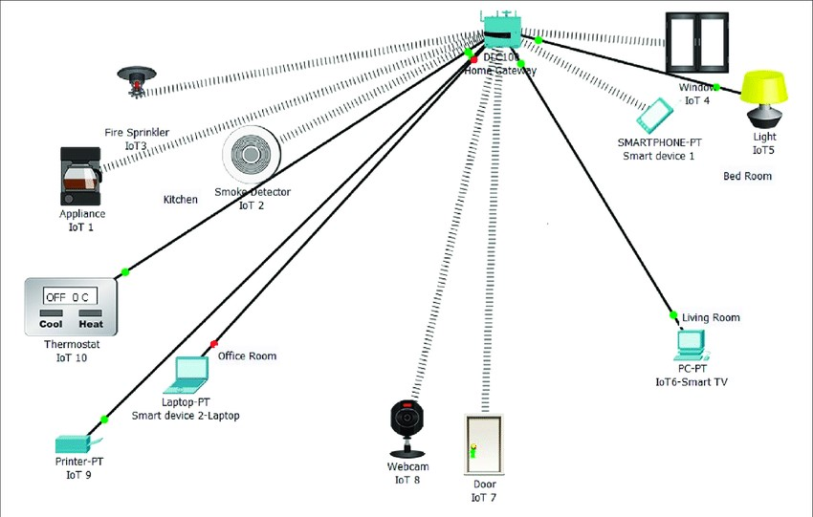

Smart LED refers to advanced lighting technology that integrates LED (Light Emitting Diode) lights with smart features, allowing for remote control and automation. These smart lights can be connected to the internet, enabling users to control them through mobile apps, voice commands, or automated schedules. They offer various functionalities, such as adjusting brightness, changing colors, and responding to motion, which enhance energy efficiency and user convenience in smart homes and businesses.

* 1. **) STREET LAMP:**

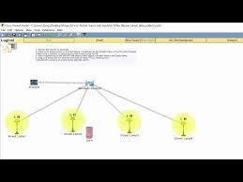

A street lamp, also known as a streetlight or lamppost, is a raised source of light positioned along roads or paths to illuminate them. These lamps often feature light-sensitive photocells that automatically turn them on at dusk and off at dawn, enhancing safety and visibility for pedestrians and vehicles. Street lamps are essential components of urban infrastructure, contributing to public security and navigation in towns and cities.

* 1. **) RFID CARD:**

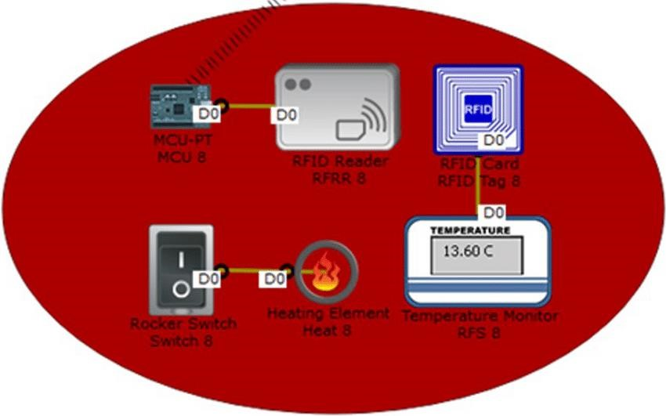

An RFID card is a type of identification card embedded with radio frequency identification (RFID) technology, allowing it to communicate wirelessly with RFID readers. These cards typically contain an integrated circuit and an antenna, enabling them to store and transmit data when activated by a reader's electromagnetic signals. RFID cards are commonly used for access control, payment systems, and inventory tracking, offering a convenient and efficient way to manage identification and transactions without direct contact.

* 1. **) RFID READER:**



An RFID reader is a device that uses radio

frequency waves to communicate with and retrieve data from RFID tags. It consists of an antenna, transceiver, and decoder, which activate the tag so it can exchange data. RFID readers can be fixed or mobile, and are used in various applications like access control, inventory management, and asset tracking to automatically identify and locate tagged objects.

* 1. **) ATM PRESSURE MONITOR:**

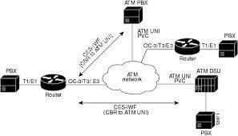

An ATM (Atmosphere) pressure monitor is a device used to measure atmospheric pressure, which is the force exerted by the weight of air in the Earth's atmosphere. These monitors typically use a barometer, which can be an aneroid, mercury, or digital sensor, to detect changes in atmospheric pressure. Atmospheric pressure data from ATM monitors is important for weather

forecasting, aviation, and various scientific applications that require precise pressure measurements.

* 1. **) FAN:**

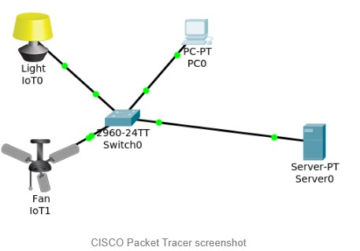

Electric fans have a motor that turns a shaft on which there is an impeller. The turning impeller creates air pressure, causing air flow. If the fan moves air in the same direction as its shaft, it is axial flow.

* 1. **) SOLAR PANEL:**

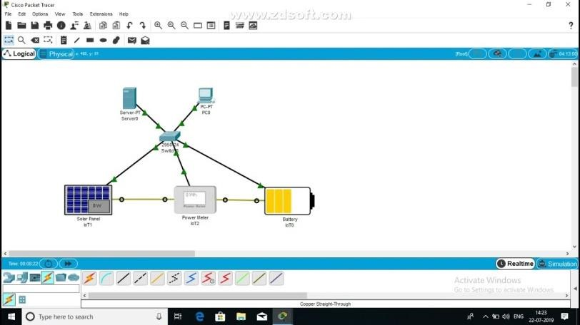

A solar panel in digital communication refers to a device that converts sunlight into electrical energy, which can be used to power communication systems or devices. These panels can also be utilized in innovative applications such as Visible Light Communication (VLC), where they serve as receivers for data transmitted via light. By harnessing solar energy, they provide a sustainable power source for various digital communication technologies, enhancing energy efficiency and reducing reliance on traditional power sources.

* 1. **) POWER METER:**

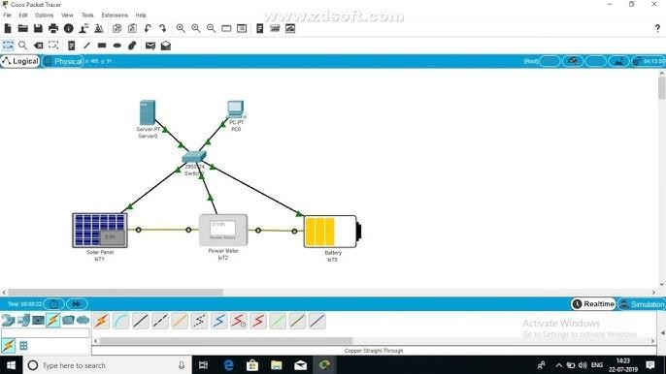

* + 1. power meter in digital communication is an advanced device used to measure and analyze electrical power consumption and various electrical parameters in real-time. These meters can connect to communication networks, allowing for remote monitoring and management of energy usage through protocols like Modbus, GPRS, and Wi-Fi. By providing accurate data on energy consumption, power meters facilitate better energy management and efficiency in both residential and industrial applications.

* 1. **) CARBON MONOXIDE DETECTOR:**

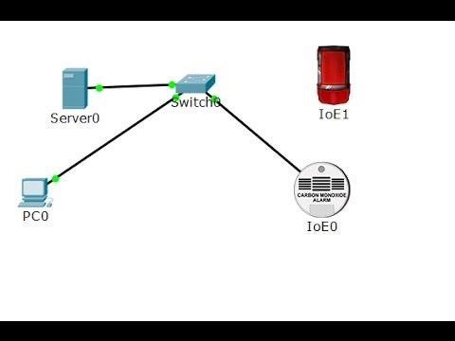

A carbon monoxide detector is a safety device designed to detect the presence of carbon monoxide (CO), a colorless, odorless, and poisonous gas that can be produced by fuel-burning appliances, vehicles, and other combustion processes. These detectors serve as an essential warning system against the dangers of carbon monoxide poisoning, which can occur from faulty appliances or improper ventilation, leading to serious health risks or even death.

* 1. **) WIND DETECTOR:**

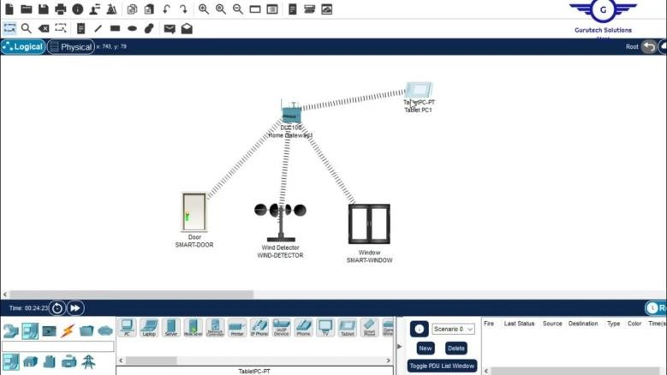

In meteorology, an anemometer is a device that measures wind speed and direction. It is a common instrument used in weather stations.

* 1. **) BATTERY:** 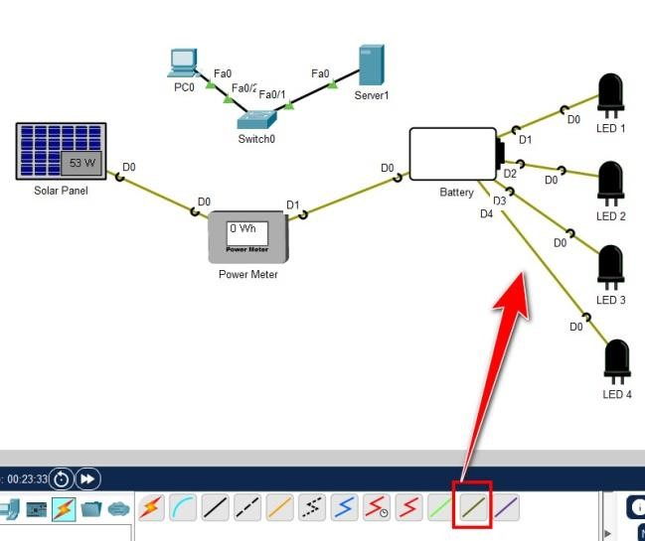

A battery is a device that stores electrical energy and supplies power to electronic devices, enabling their operation in portable and mobile applications. In digital communication, batteries are crucial for powering devices such as smartphones, laptops, and IoT devices, allowing for uninterrupted connectivity and communication without reliance on direct power sources.

1. **INDUSRIAL:** 
   1. **) WIND TURBINE:**

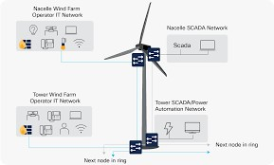

* + 1. wind turbine is a device that converts the kinetic energy of wind into mechanical energy, which is then transformed into electricity. It typically consists of large blades mounted on a tall structure, where the wind causes the blades to rotate, driving a generator to produce electrical power. Wind turbines are commonly grouped together in wind farms, contributing to renewable energy generation and reducing reliance on fossil fuels.

* 1. **) FIRE MONITOR:**

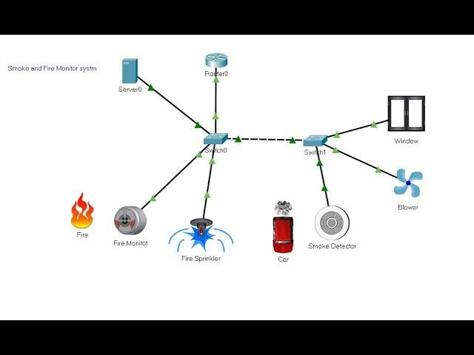

* + 1. fire monitor, also known as a water cannon or fire-fighting gun, is a crucial component of fire suppression systems designed to deliver large volumes of water or extinguishing agents to combat fires. These devices can be portable, fixed, or remotely controlled, allowing firefighters to direct high-pressure water streams in various patterns for effective fire suppression. Fire monitors are commonly used in high-risk environments such as industrial facilities, refineries, and marine settings, enhancing safety by enabling firefighters to operate from a safe distance.

* 1. **) FIRE SPRINKLER:**



A fire sprinkler is a crucial component of a fire protection system designed to automatically detect and suppress fires. When the temperature reaches a predetermined level, typically due to heat from a fire, the sprinkler activates and discharges water to control or extinguish the flames. Fire sprinklers are widely used in residential, commercial, and industrial settings, significantly enhancing safety by minimizing fire damage and allowing occupants time to escape. They operate independently, meaning only the sprinklers nearest to the fire will activate, maximizing water efficiency.

* 1. **) TRIP SENSOR:**

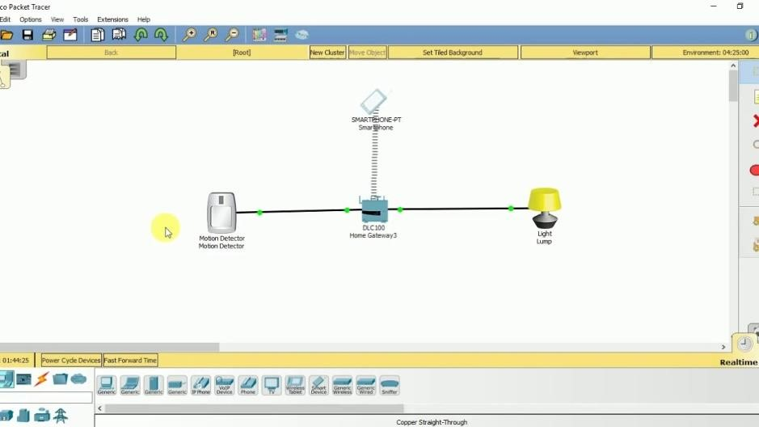

A trip sensor is a device designed to detect specific conditions or events that trigger a protective response, such as shutting down machinery or activating alarms. Commonly used in electrical systems, these sensors monitor parameters like current or temperature and "trip" or disconnect the circuit when unsafe levels are detected, preventing potential damage or hazards. Trip sensors are essential for ensuring safety in various applications, including industrial equipment, electrical panels, and automated systems.

* 1. **) WIND DETECTOR:**



In meteorology, an anemometer is a device that measures wind speed and direction. It is a common instrument used in weather stations.

* 1. **) SIGNAL GENERATOR:**

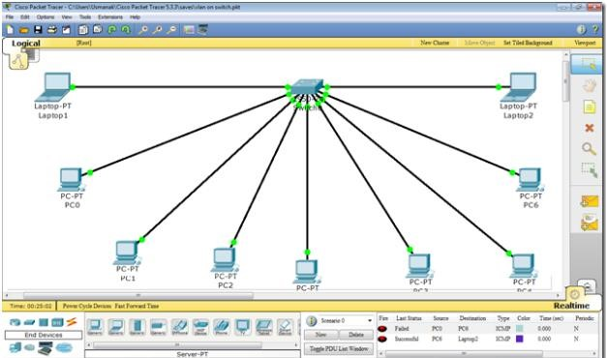

A signal generator is an electronic device that produces repeating or non-repeating electrical waveforms, which can be used to test and evaluate electronic equipment. These devices generate various types of signals, including sine waves, square waves, and pulses, across a range of frequencies, making them essential for designing, manufacturing, and servicing electronic devices. Signal generators are widely used in applications such as telecommunications, audio testing, and circuit development, providing a controlled stimulus for testing purposes.

* 1. **) BATTERY:**

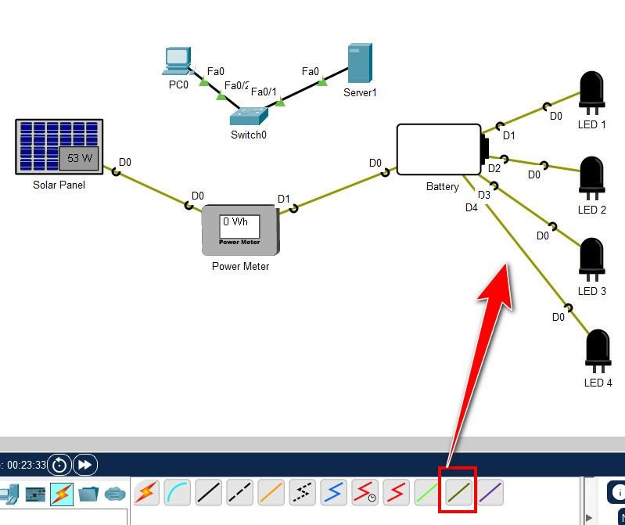

A battery is a device that stores electrical energy and supplies power to electronic devices, enabling their operation in portable and mobile applications. In digital communication, batteries are crucial for powering devices such as smartphones, laptops, and IoT devices, allowing for uninterrupted connectivity and communication without reliance on direct power sources.

* 1. **) POWER METER:**



A power meter in digital communication is an advanced device used to measure and analyze electrical power consumption and various electrical parameters in real-time. These meters can connect to communication networks, allowing for remote monitoring and management of energy usage through protocols like Modbus, GPRS, and Wi-Fi. By providing accurate data on energy consumption, power meters facilitate better energy management and efficiency in both residential and industrial applications.